

AI Assisted Coding

**Assignment 3.5**

**Name: Vivek Hallticket:2303A52009 Task-01**

Prompt: py function to check whether a given year is leap year or not

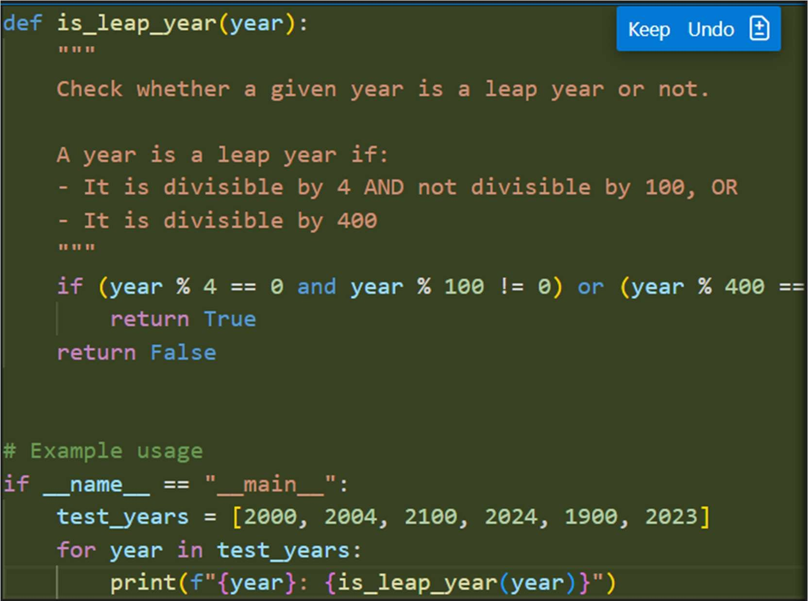

Output:

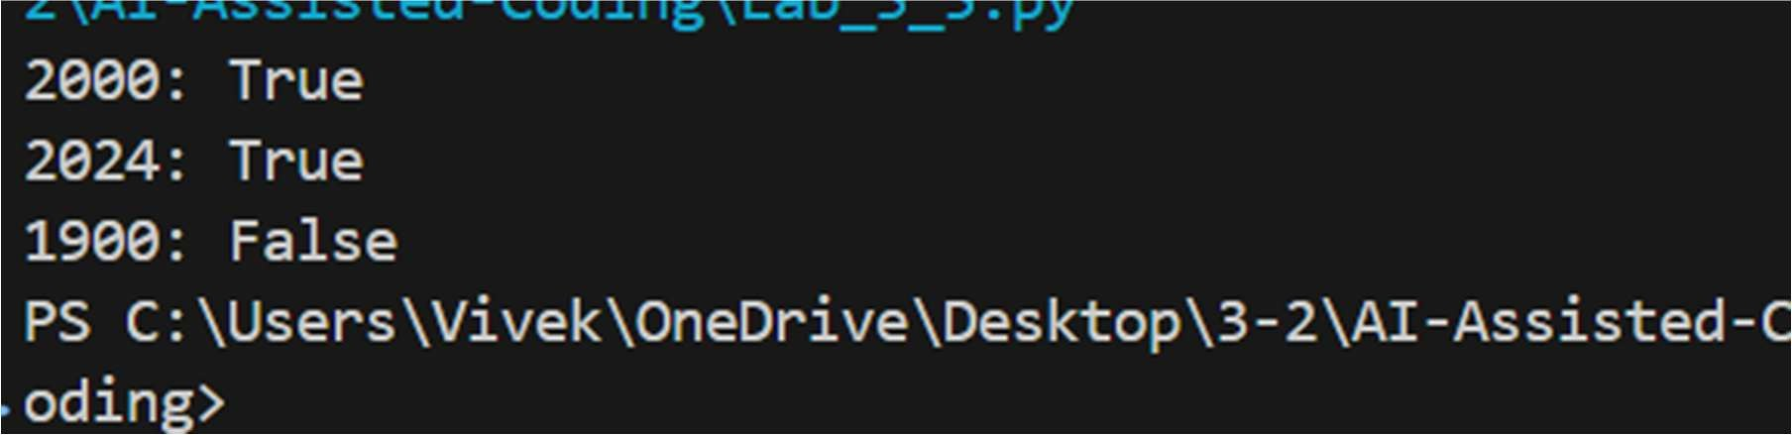



Task-02

**Prompt:** Write a Python function to find the Greatest Common Divisor (GCD) of two numbers.

Example:

Input: 12, 18

Output: 6

The function should take two integers as input and return their GCD.

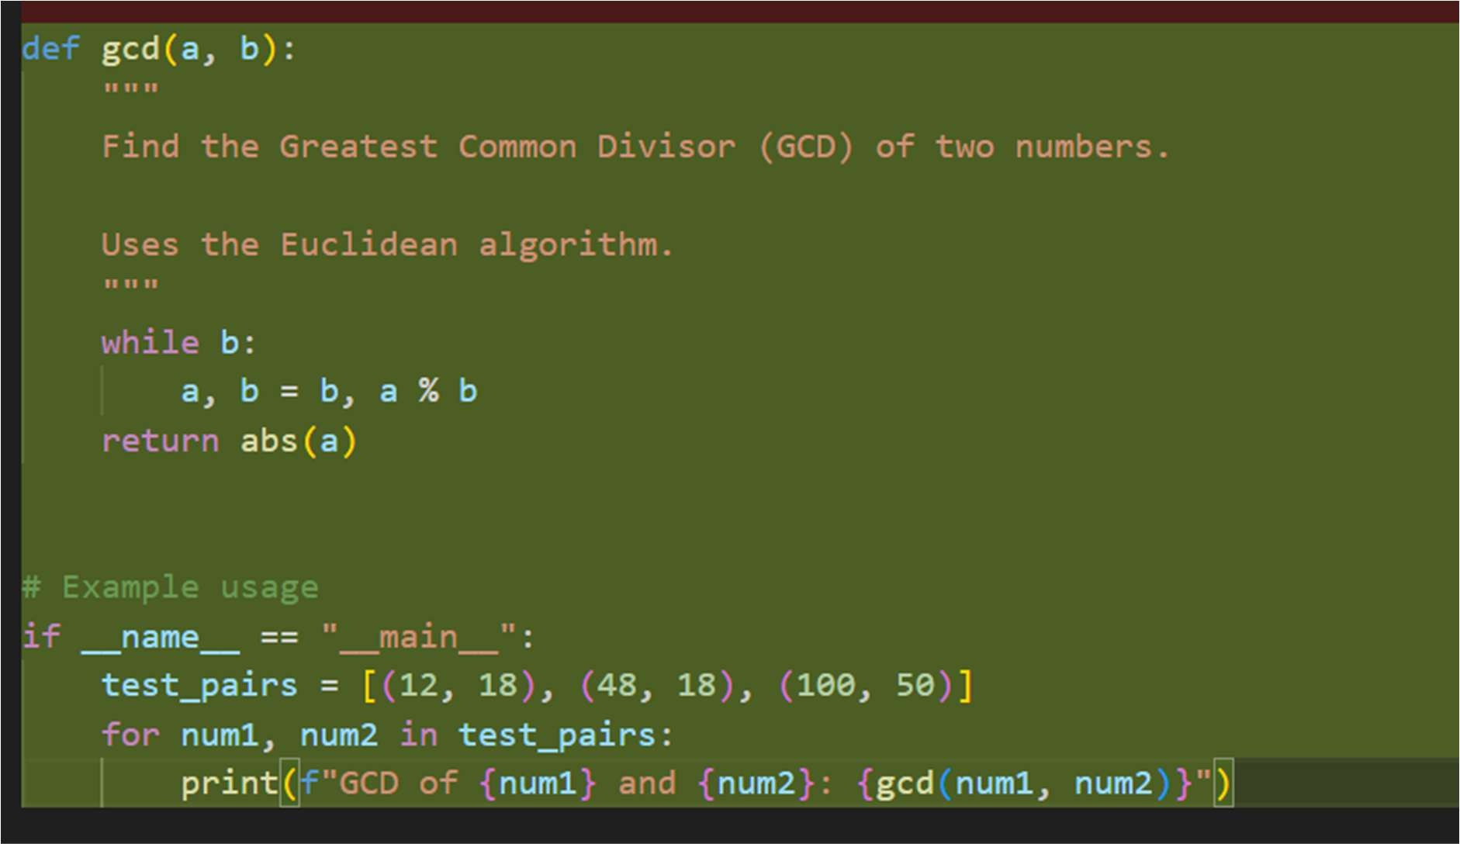

Output:

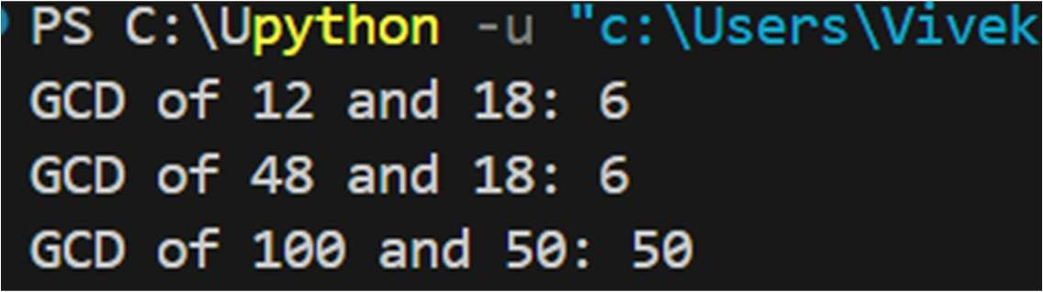



Task 03 prompt:

Write a Python function to compute the Least Common Multiple (LCM) of two numbers.

Examples:

Input: 4, 6 Output: 12

Input: 5, 10 Output: 10

Input: 7, 3 Output: 21

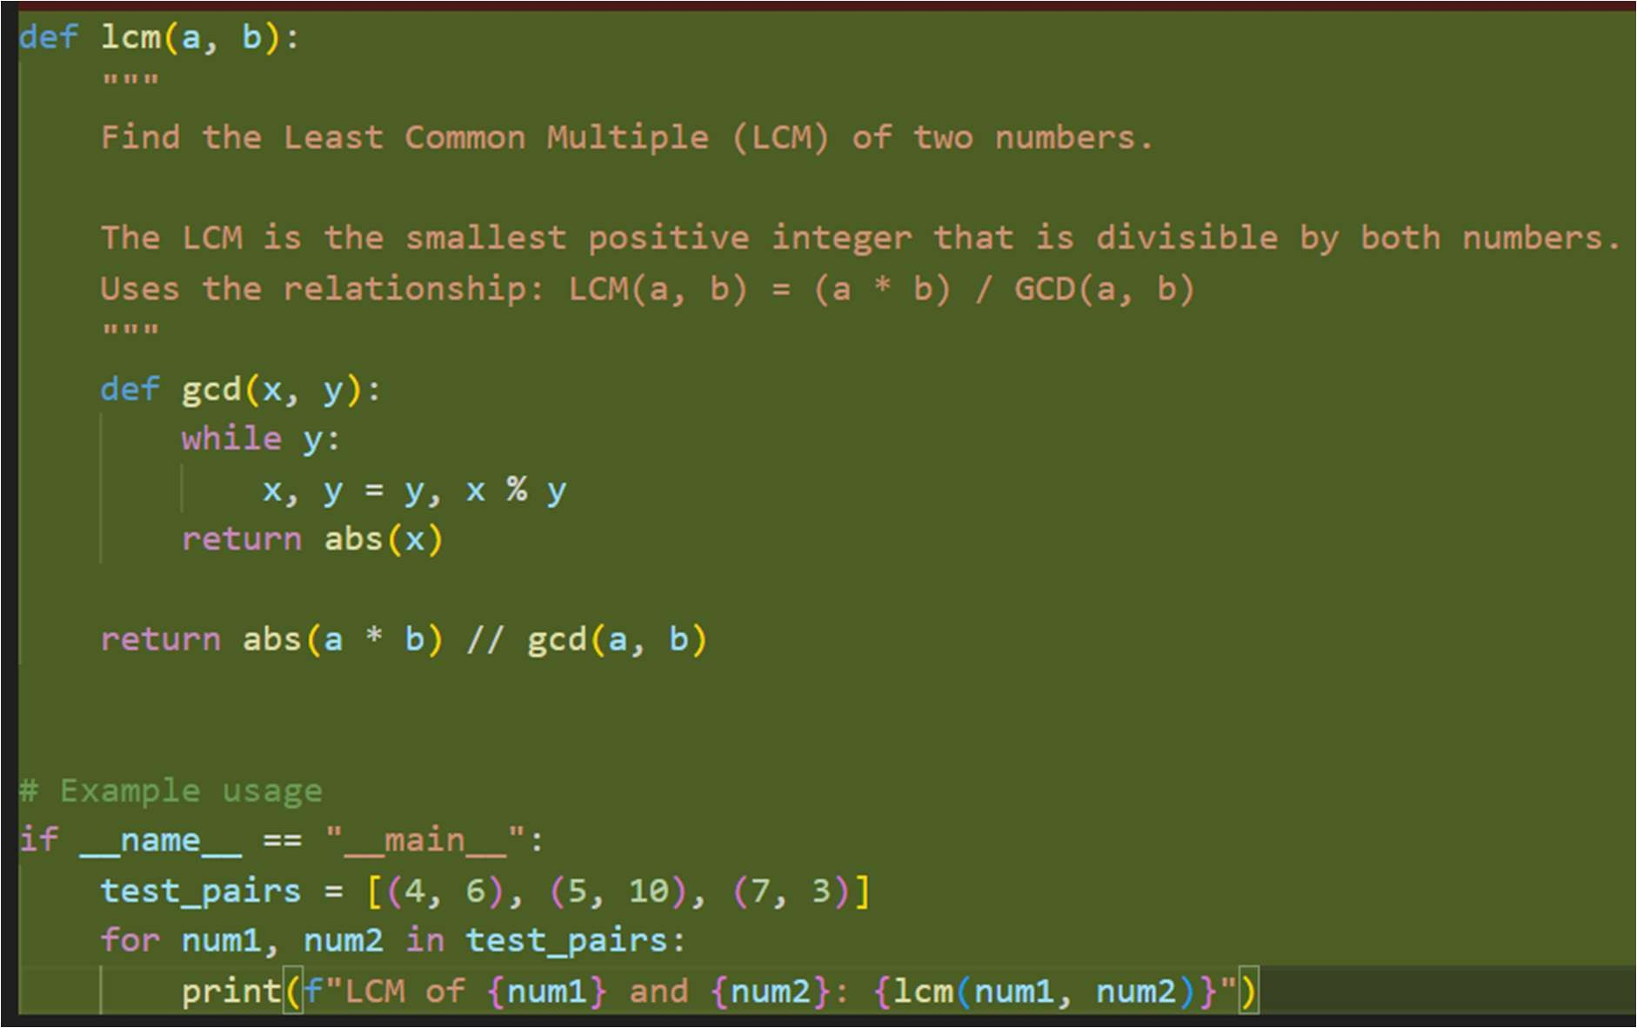The function should take two integers as input and return their LCM. CODE:

Output:

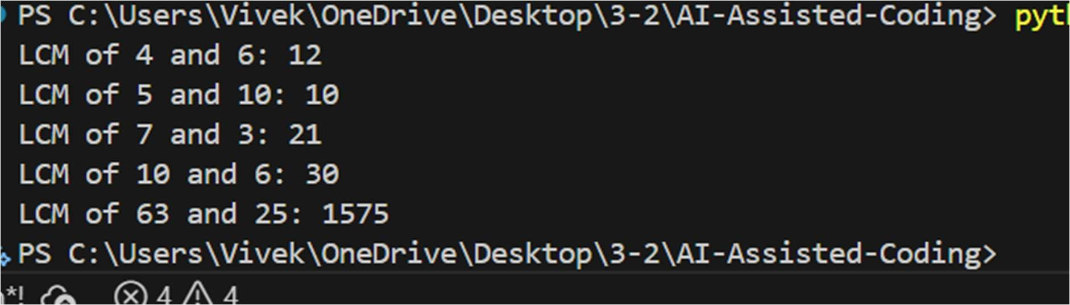



Task 4 :

Write a Python program to convert a binary string to its decimal value. Also give explanation whether the input is valid or invalid Test the program using multiple valid and invalid binary examples.

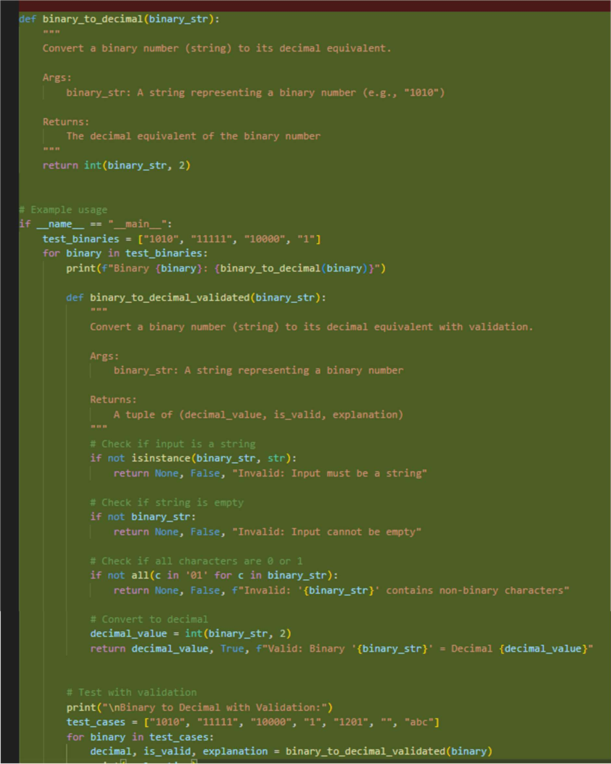

Output:



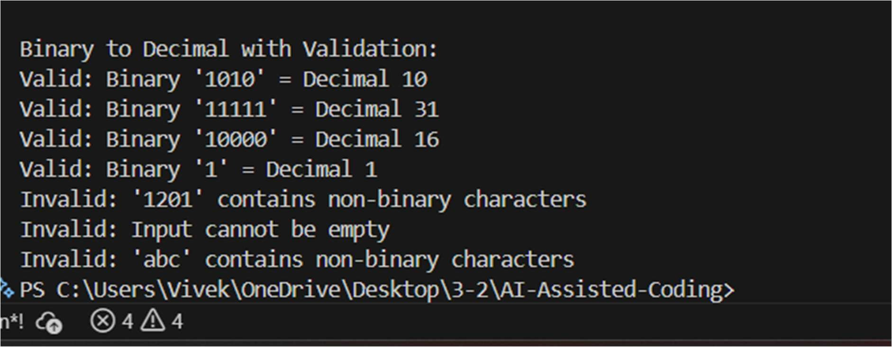

Task-5 prompt :

generate a Python function that converts a decimal number to binary. Example:

Input: 10 → Output: 1010

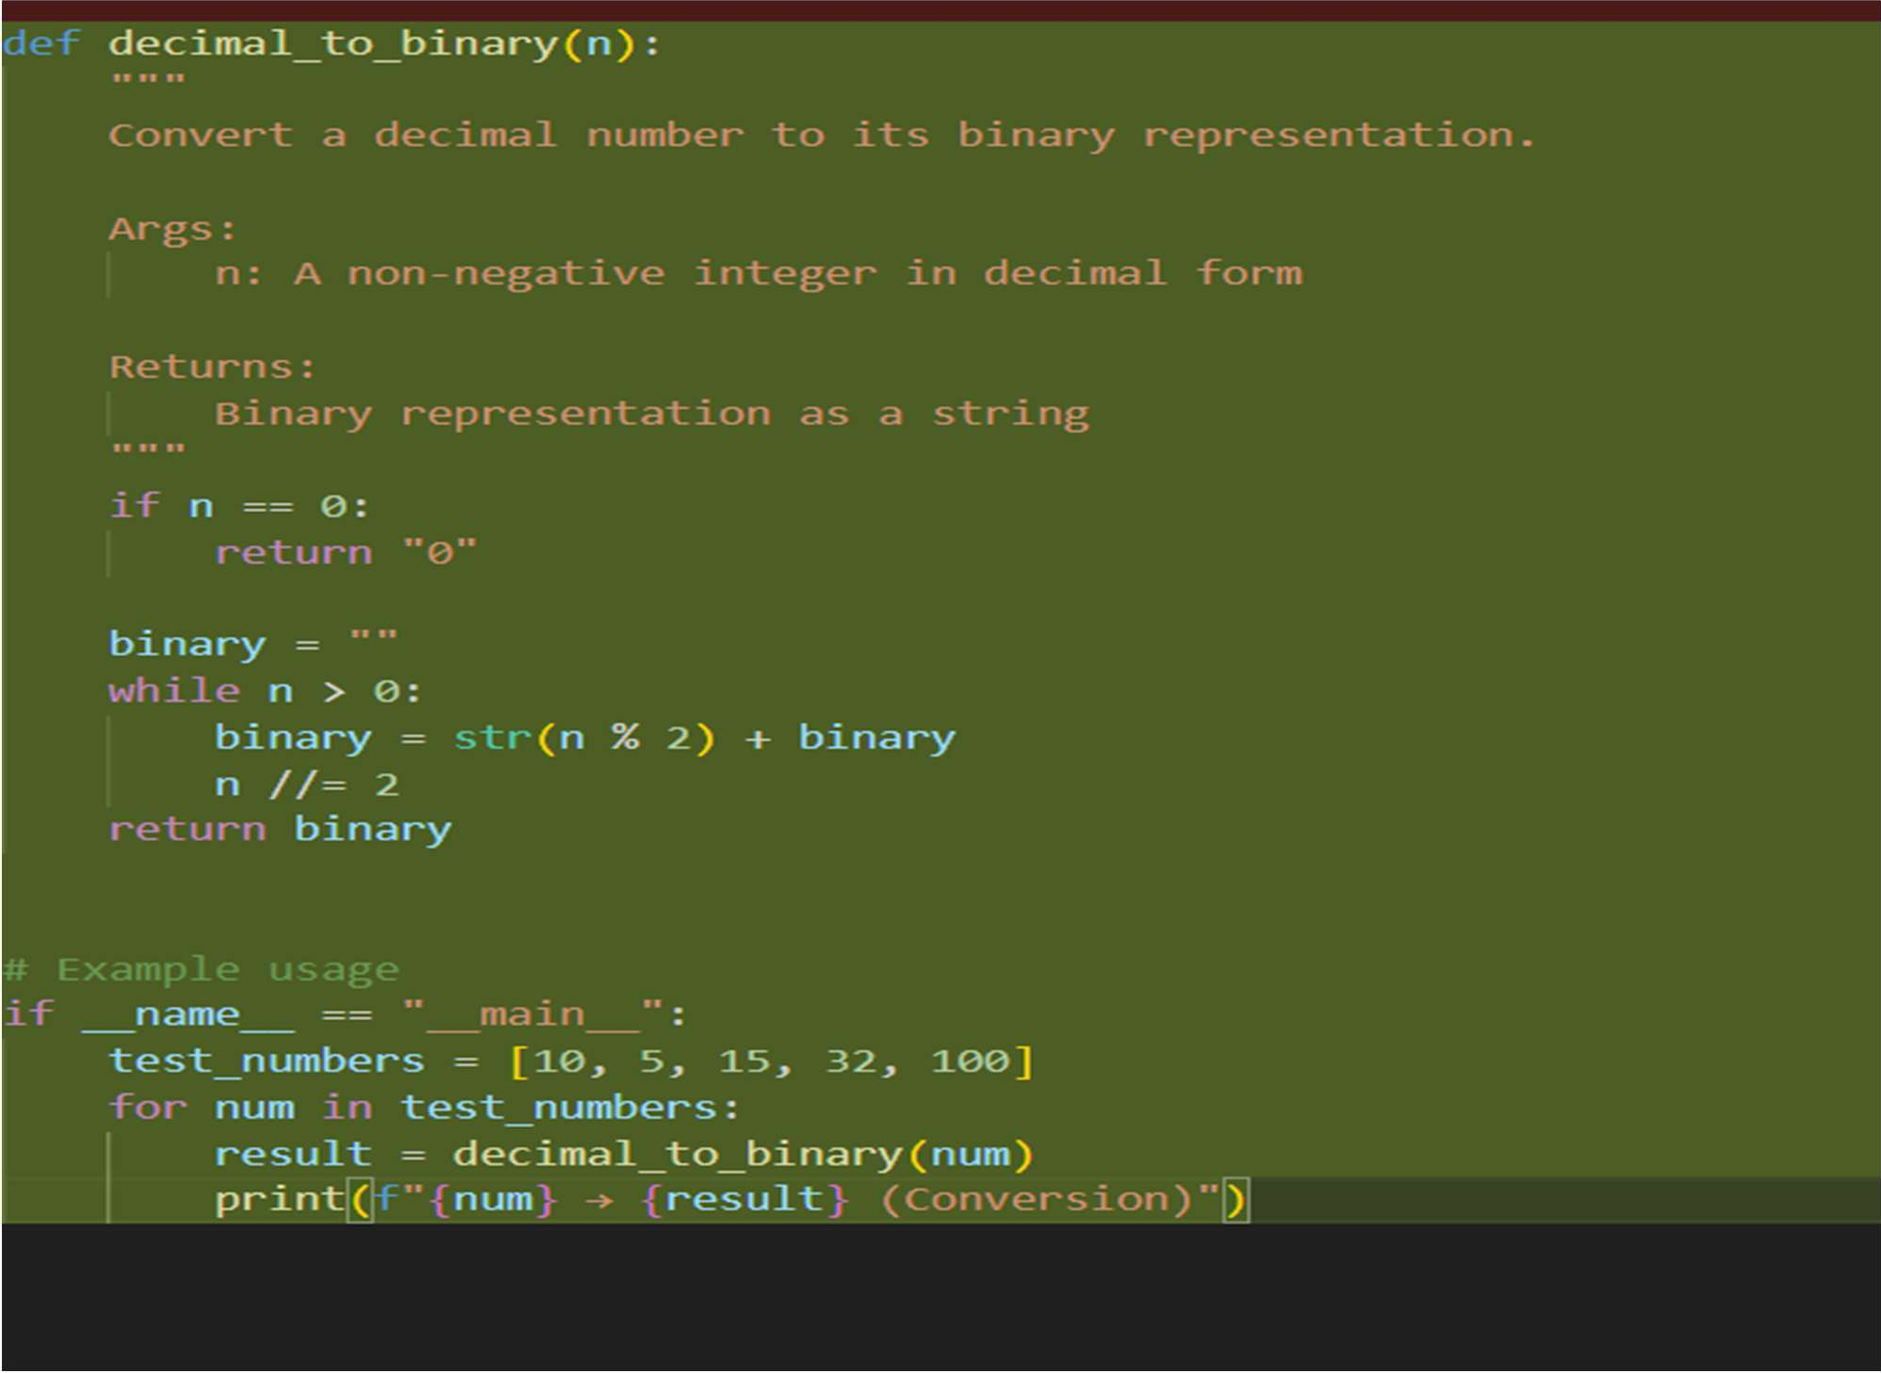also give a one word explanation for outputs Code:



Output:

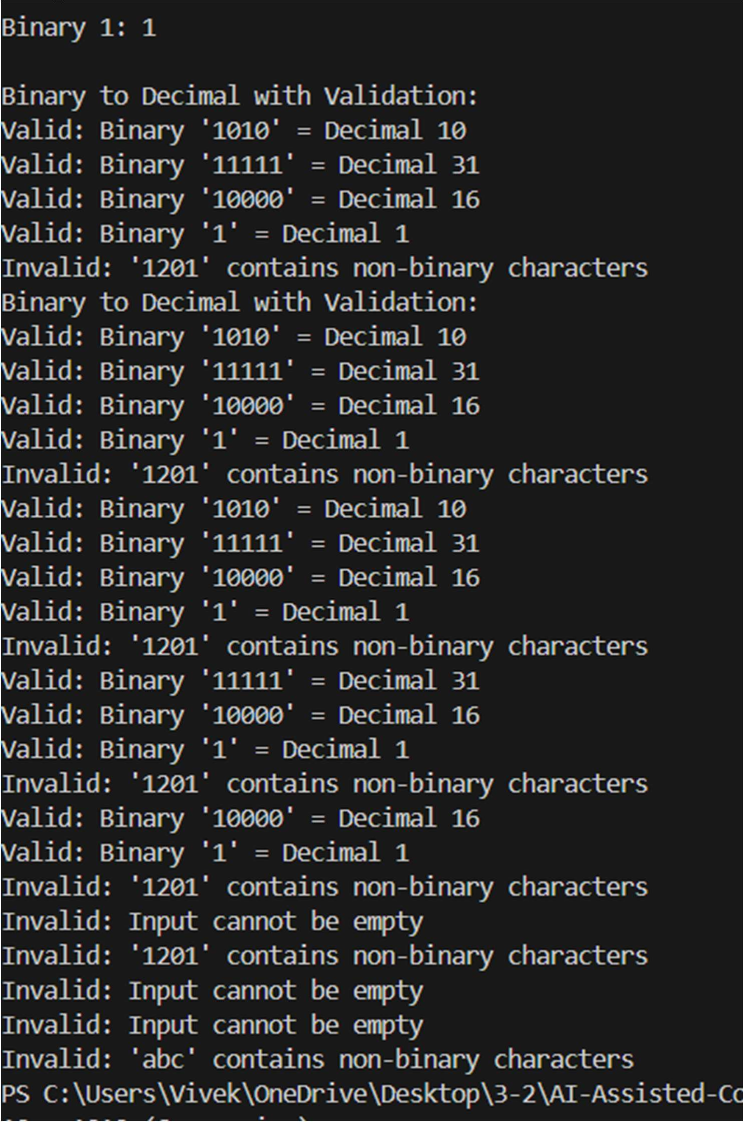

Task-06:

Prompt:

Write a Python function to check whether a given number is a Harshad (Niven) number.

Examples:

Input: 18 Output: Harshad Number



Input: 21 Output: Harshad Number

Input: 19 Output: Not a Harshad Number

The function should calculate the sum of digits and check divisibility. Also test boundary conditions such as single-digit numbers, zero, and negative values to ensure robustness.

Code

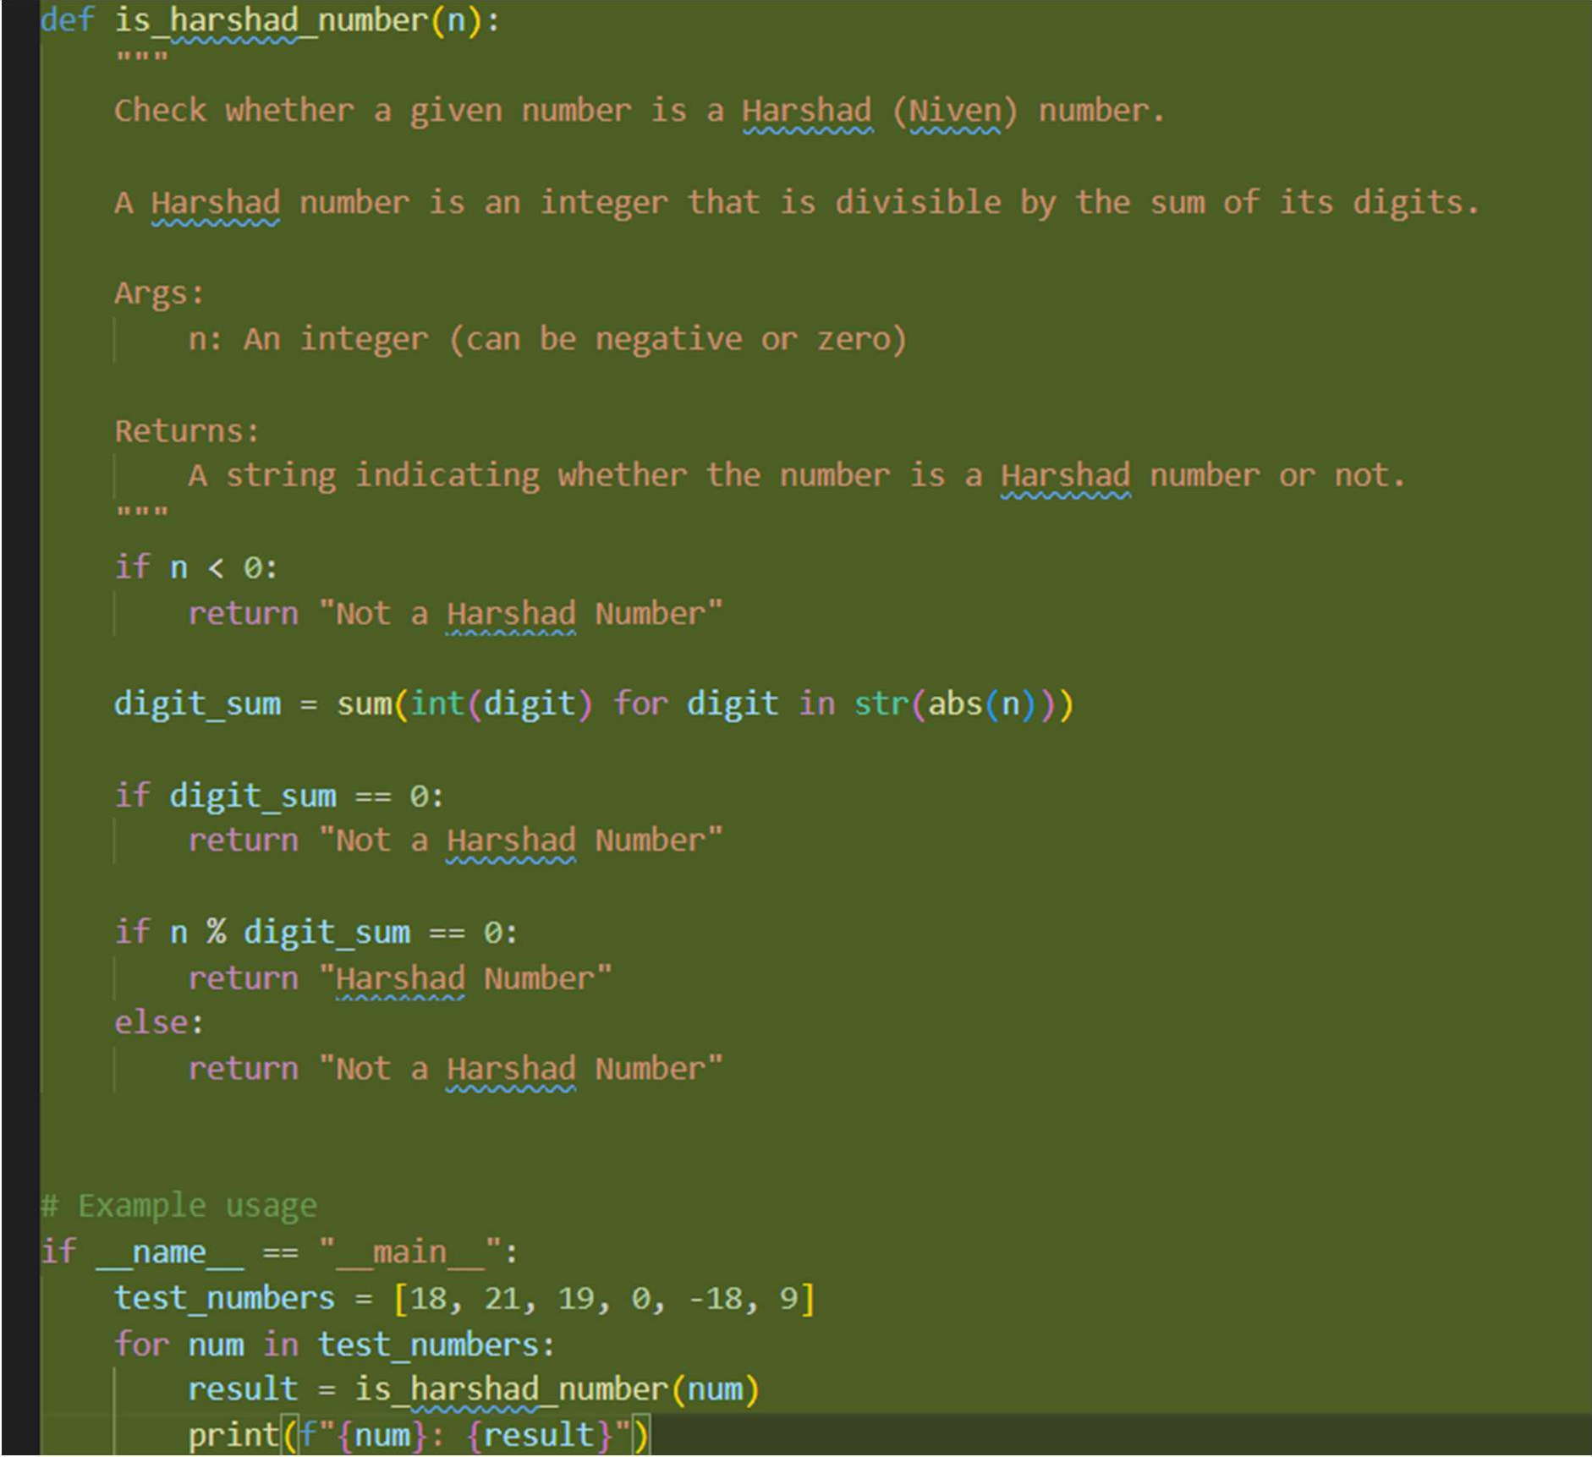

Output:

